Response to Reviewer 1 Comments

In this manuscript, the authors, Davidi et al have investigated the effect of TTFields in HCC cells and an animal model, alone or in combination with sorafenib. Overall, the authors believe that this

research demonstrates potential for concomitant TTFields and sorafenib application in the treatment of HCC. I read the manuscript with interest and commend the authors for the work done in the area of liver cancer treatment. However, I feel that the experiments around this concept were not designed well enough to support their new findings. I have raised the following concerns which is necessary to make this manuscript more scientifically interesting.

**Point 1:** What is the rationale of using 150 kHz TTFields? TTFields at 100 kHz has also shown significant differences as cytotoxicity at p<0.01 and p<0.001 in HepG2 and Huh-7D12 cells which have around 60% and 50% of cell survival. Why did the authors use high frequency of TTFields though the cytotoxicity was also observed in lower dose (Fig 1A).

**Response 1**: We thank the reviewer for this important question and would be happy to clarify. TTFields are alternating electric fields in the range of 100 to 500 kHz, with maximal efficacy seen at a different frequency for different tumor types. Since TTFields cannot be applied at several different frequencies simultaneously, one specific frequency needs to be selected, and so the first step in examination of a new tumor type is a frequency scan. The effect of TTFields is not dichotomic, such that only one frequency is effective while the other are not at all. From the frequencies showing efficacy the purpose is to select the most effective one.

It should be clarified that higher frequencies of the alternating electric fields do not mean higher energy, and hence there is no disadvantage in working with higher frequencies and no added toxicity or increased side effects for higher frequencies within the TTFields frequency range. Of note, TTFields at 200 kHz is already approved and has been applied to more than 18,000 patients with glioblastoma, with skin irritation being the main treatment related adverse event. TTFields at 150 kHz is approved for treatment of unresectable malignant pleural mesothelioma.

To address these issues, we have rephrased the discussion: “It has been previously shown that maximal effectivity of TTFields occurs at a different frequency for different cancer types, owing to the specific electrical properties of the cells [15, 28]. Hence, the first step in applying TTFields to a new tumor type includes frequency scans.” and “The lower TTFields intensity required for treatment of HepG2 relative to Huh-7D12 cells for achieving the same level of efficacy suggest higher sensitivity of the former to TTFields.”

**Point 2:** What is the ‘n’ number of the samples and experiments in each group? Also mention the ‘n’ number in all the experiments involved for invitro and invivo.

**Response 2:** We thank the reviewer for pointing this was not clear. As mentioned in the statistical analysis sub-section within the methods part, all in vitro experiments were repeated at least 3 times, and so depicted values are mean (*N* ≥ 3) ± SEM. We have now added this also to the legends of figures 1, 2, and 3. Per the in vivo study, as was mentioned in the methods (sub-section 2.8), 52 animals were included in the study. The specific numbers in each treatment group are now mentioned in the results (sub-section 3.4): “During the treatment period, average tumor volumes of control animals (*n* = 11) increased 5.9-fold (Figure 4b and 4c; and Figure S3 for tumor images). For animals treated with TTFields (*n* = 15) or sorafenib (*n* = 10), tumor growth was significantly lower, 3.3- and 2.3-fold, respectively. In the TTFields-sorafenib combination group (*n* = 16), a 1.6-fold increase in tumor volume within the treatment period was observed, a growth significantly lower than that for control or for each treatment alone.” It is also mentioned in the legend of figure 4: “Rats (*n* = 52) were inoculated orthotopically with rat HCC N1S1 cells, and treated with sham-vehicle (*n* = 11), TTFields alone (*n* = 15), sorafenib alone (*n* = 10), or TTFields + sorafenib (*n* = 16), according to the depicted timeline (a).”

**Point 3:** LC3 is increased in all the groups except in control tissue, however, cell death was increased only in combined group. How can the authors correlate autophagy with apoptosis? It is not so trustworthy that the only expression of LC3B indicate the treated condition have increased autophagy in the tumor tissue. Other important autophagy and degradation markers like Beclin1 and P62 need to be shown to reflect the regulatory mechanism of TTFields, as well as for the combined treatment with Sorafenib.

**Response 3:** We sincerely appreciate this well-taken comment. First, we would like to emphasize that indications of autophagy were diverse and determined from increased cellular granularity, amplified lipidation of LC3 (from LC3-I to LC3-II) detected by Western blot, and elevated levels of LC3 foci observed by fluorescent staining. Nevertheless, to better explain the correlation between autophagy and apoptosis we have performed additional examinations to include more markers and additional time points. As per the reviewer’s request, these examinations were performed for the combined treatment as compared to TTFields and sorafenib alone. We thank the reviewer for this comment, as these additions add much clarity to the mechanism of action of TTFields in combination with sorafenib and provide a more coherent explanation for the in vivo results. These additions may be seen in Figure 3 and are described in results sub-section 3.4, Autophagy-apoptosis Interplay For Treatment with Concomitant TTFields and Sorafenib: “In order to investigate the mechanism of action of TTFields-sorafenib co-application, HepG2 and Huh-7D12 cells were treated for 6, 24, or 48 hours with TTFields, sorafenib (3µM), or the two modalities together, and then examined for expression levels of various proteins. For HepG2 cells, the autophagy marker beclin-1 demonstrated elevation after 6 hours of treatment, which was later replaced with diminished expression levels (Figure 3d). This type of behavior was seen in all treatment groups, but was most pronounced for TTFields-sorafenib co-application. The autophagy marker LC3 also displayed such bi-phasic characteristics, but with a somewhat slower kinetics, showing some elevation at 6 hours of treatment, but higher elevation at the 24 hours time point (Figure 3d). As in the case of beclin-1, the magnitude of the effect was higher for co-treatment of TTFields and sorafenib relative to the monotherapies. GRP78, a marker of ER stress, remained low in all treatment groups for 6 and 24 hours of treatment, but demonstrated elevated levels at the later, 48-hours time point (Figure 3e). The apoptosis marker cleaved PARP displayed increased expression in the combined group already after 24 hours, elevating even further after 48 hours of treatment. For the monotherapies, cleaved PARP increase was only evident at 48 hours of treatment, and to a lower extent than that in the co-treatment group (Figure 3f). The slower kinetics of the autophagy-apoptosis path in the Huh-7D12 cells, as seen from the elevation of LC3 after as much as 48 hours (Figure 2c and d), prevented from detecting such changes in the levels of these markers in this cell line (Figure S1).”And in the discussion part “Kinetic examination in the HepG2 cells revealed elevation in autophagy levels as early as 6 hours of TTFields or sorafenib treatment, which diminished and were replaced with ER stress and apoptosis for 48 hours of treatment. These results are in line with a previous study that focused on the effects of sorafenib on such markers in HepG2 cells [32]. The higher changes in expression levels and faster kinetics when TTFields and sorafenib were applied together rather than alone indicate higher stress levels imposed on the cells in the former case.”

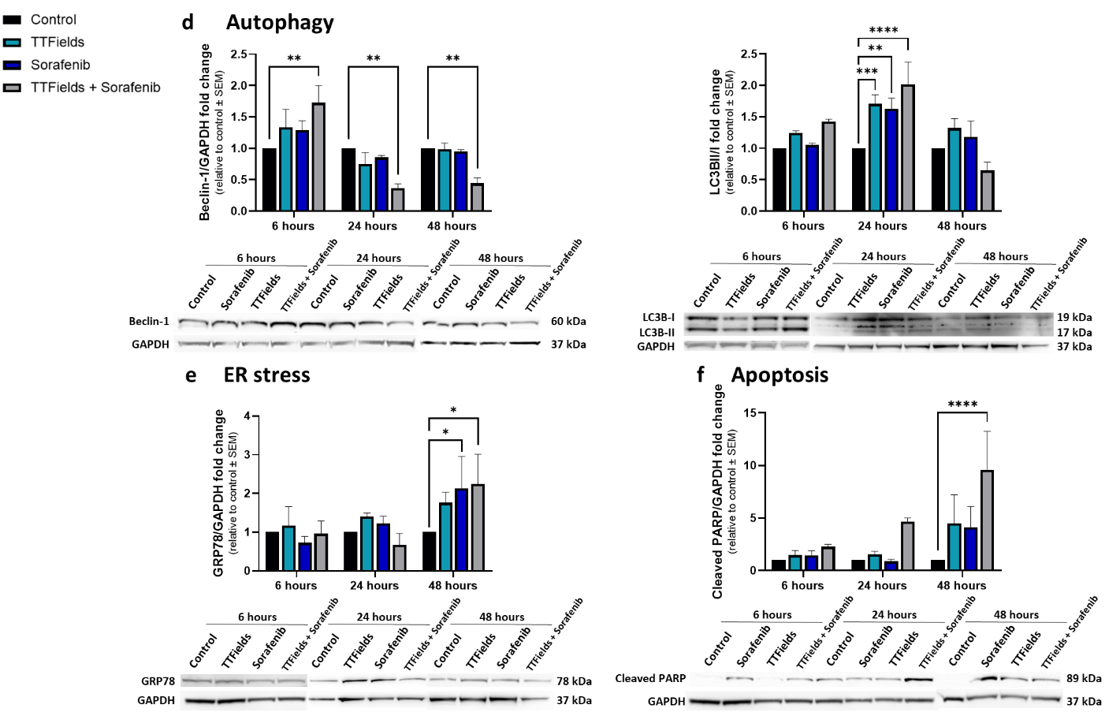

**Figure 3.** HepG2 cells were treated for 6, 24, or 48 hours with 150 kHz TTFields, 3 µM sorafenib, or the two treatments combined, followed by Western blot examination of the autophagy markers beclin-1 and LC3 (d), the ER stress marker GRP78 (e), and the apoptosis marker cleaved PARP (f). Values are mean (*N* ≥ 3) ± SEM. \**p* < 0.05, \*\**p* < 0.01, \*\*\**p* < 0.001, and \*\*\*\**p* < 0.0001 relative to time-respective control; two-way ANOVA.

In the animal study we have now added IHC examination of beclin-1 and of GRP78, a marker for ER stress, as described in results sub-section 3.4. Concomitant TTFields with Sorafenib Enhances Treatment Efficacy in Vivo: “Tumor histology and immunostaining for beclin-1 and LC3, GRP78, and cleaved PARP were performed to examine autophagy, ER stress, and apoptosis levels, respectively. Beclin-1 levels were increased more than 4-fold relative to control in all treatment groups, while intensity of LC3 staining was increased about 3-fold relative to control in the individual TTFields and sorafenib groups, but elevated only 2-fold in the combination group (Figure 4e). GRP78 levels in the groups treated with TTFields or sorafenib alone remained unchanged from the control, but were elevated 2-fold in the TTFields plus sorafenib group (Figure 4f). Additionally, the percentage of cells positive for cleaved PARP was significantly higher relative to control only in the combination group (Figure 4g).” and also in the discussion: “The lower autophagy accompanied by the higher ER stress and apoptosis displayed in the conjunction group relative to the monotherapies groups following 6 days of treatment suggest that these animals were pushed further along the autophagy-apoptosis kinetic timeline due to the higher levels of stress experienced by these animals, in accordance with the results described for the cell cultures.”

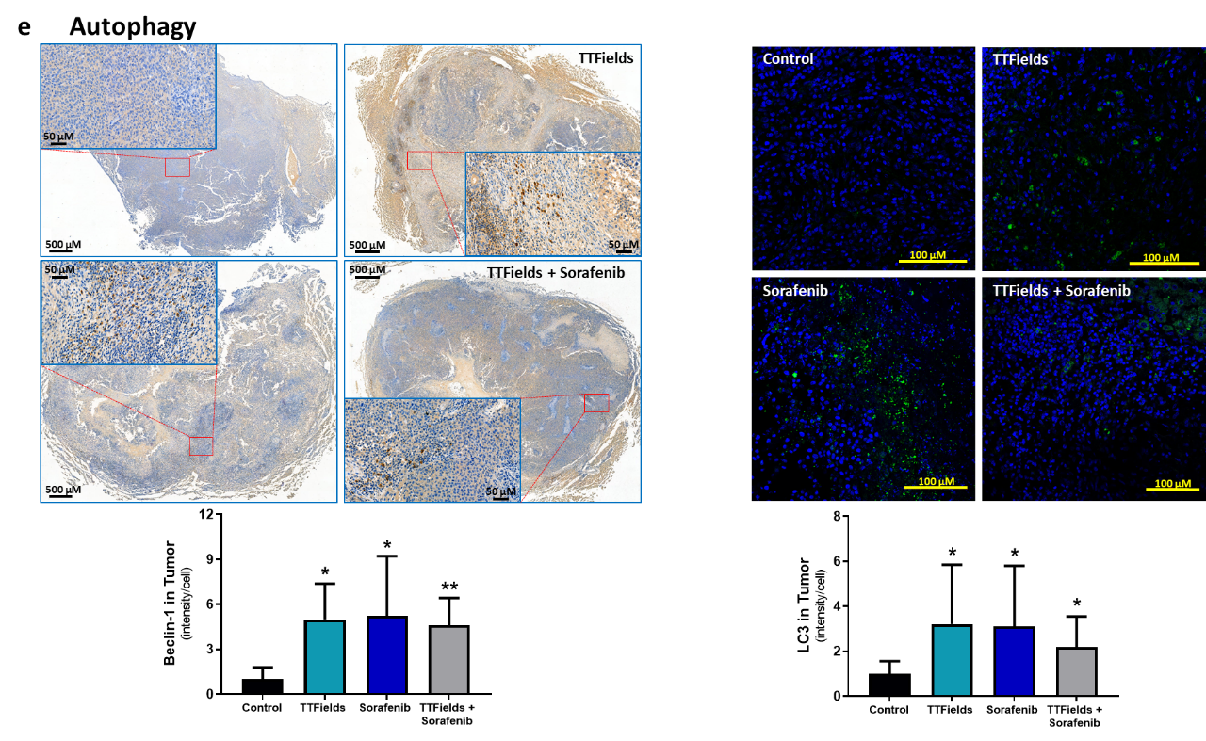

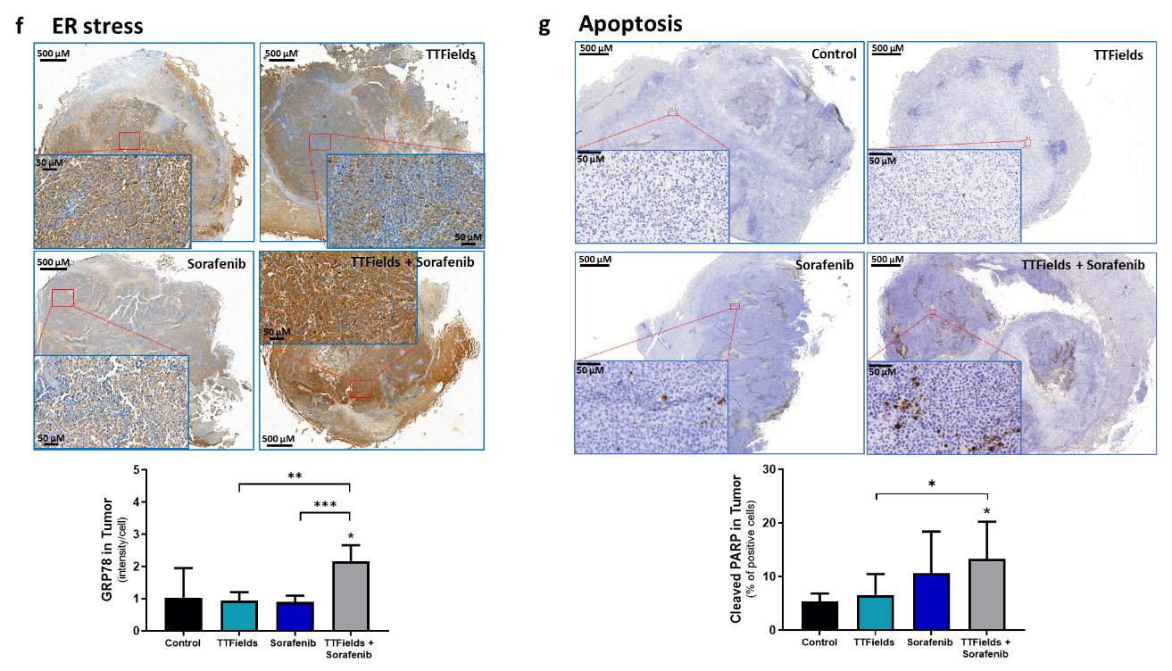

**Figure 4.** tumor slices were subjected to immunohistochemical analysis for beclin-1 and LC3 (e), GRP78 (f), and cleaved PARP (g). Values are mean ± SD. \**p* < 0.05, \*\**p* < 0.01, and \*\*\*\**p* < 0.0001 relative to control for labels above bars, or between indicated groups; Student’s T-test.

**Point 4:** What was the total weight of livers in all groups? Please update the images of whole liver showing tumors on it, or at least pictures of tumors which were removed after sacrifice, if applicable. Several data have shown very high error bars in each group (especially Fig Can the author provide the tumor images which were harvested from mice?

**Response 4:** Per the reviewer’s request we show below images of the tumors within the liver, which we have also provided now in the supporting material of the paper. As may be seen, the liver itself is much larger than the tumor, and so we did not see value in measuring total liver weight, and hence cannot provide these values. While we tried to reduce variability between the animals by excluding those that at treatment initiation had tumor volumes not within the range 30–100 mm3, there was still divergence between the animals that resulted in the standard deviation bars depicted in the figure. It is however important to mention that there was a very good correlation between tumor volume (as measured by MRI) versus tumor weight at the end of the study, as may be seen in the graph below.

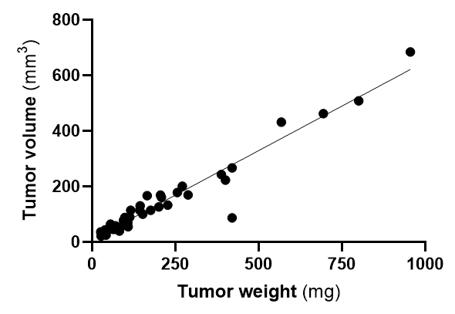

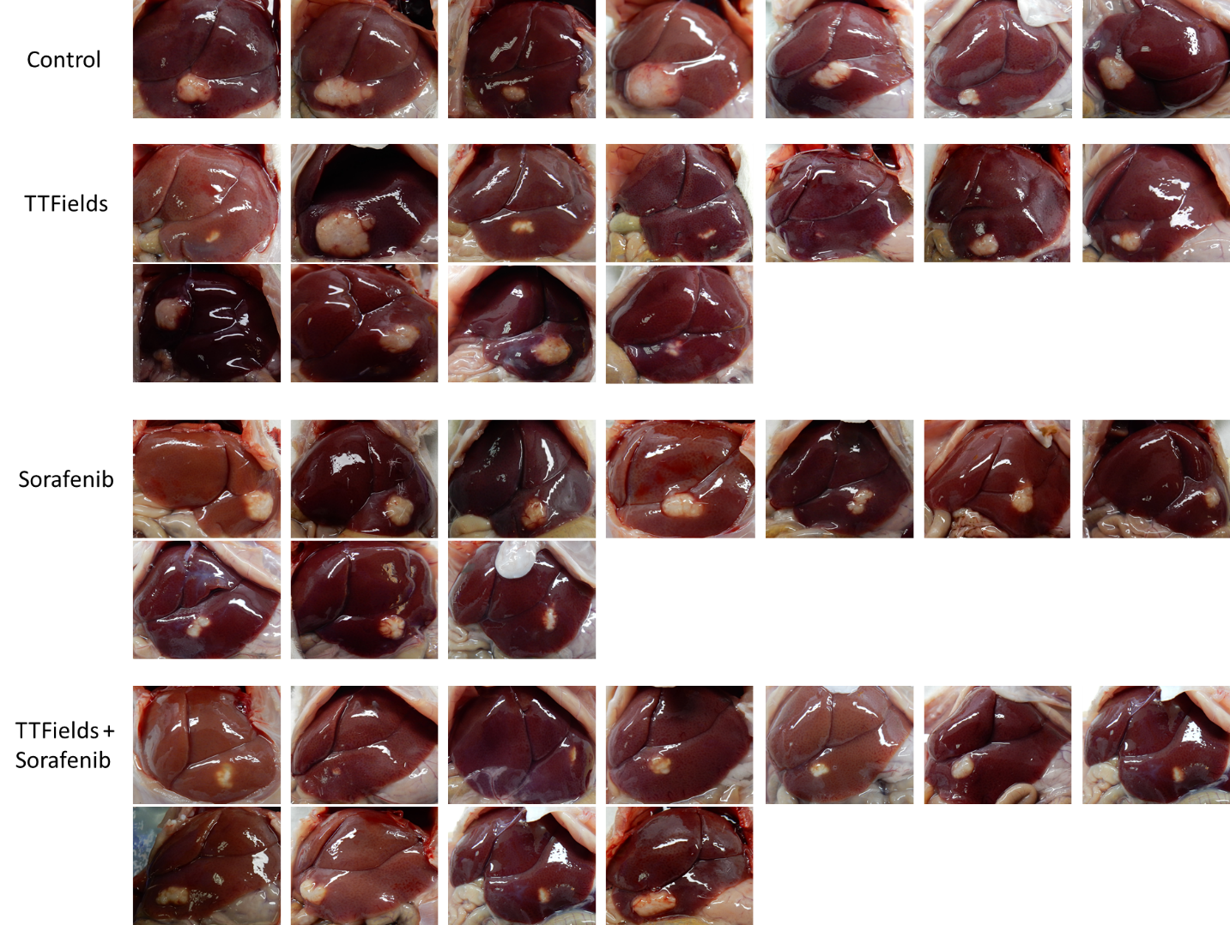

**Figure S3.** Images of tumors within the livers of the rats treated with sham heat (control rats), TTFields, sorafenib, or TTFields plus sorafenib.

**Point 5:** In the IHC experiment for PARP, the authors have incubated with primary antibody only for 30 min? Is that timing enough to get protein expression? What source of secondary antibody was used? In addition to IHC, I suggest performing western blot using PARP antibody where the full length and cleaved bands are observed in the same blot.

**Response 5:** We thank the reviewer for this question. IHC tests the presence of a protein already expressed in the tissue, and 30 min are sufficient to allow recognition and binding of the antibody to the target protein. The secondary antibody is an HRP conjugated goat anti rabbit, that is a part of the Leica HRP-refine detection kit (Cat # DS9800). We have added the missing antibody information to section 2.10. We unfortunately do not have any tissue left to allow for performing WB analysis from the in vivo study, but we have conducted additional cell line studies and added WB analysis of cleaved PARP for the in vitro examinations and additional IHC examinations for autophagy and ER stress markers (as shown in response 3).

**Point 6:** The figure number is mislabeled in Fig 4D-LC3 Immunofluorescence.

**Response 6:** We thank the reviewer for identifying this mistake, and have corrected this, changing the label of the LC3 data to e.

**Point 7:** Why there is no error bar in the control group of all bar graphs? Please include error bars and re-calculate the statistical analysis for all the data wherever missing.

**Response 7:** We appreciate this question. Error bars are not missing for the control groups, rather they are null, as the values displayed in these figures are relative to control, and so per definition all control experiments have the exact same value of 100 or 1 (for percentage or fold change, respectively).

**Point 8:** Figure legends of Fig2D is missing. Fig C is repeated in the legend. Please label the figures appropriately. It is so frustrating to understand.

**Response 8:** We apologize for this mistake, and have now corrected the figure legend. The quantification of immunofluorescence of LC3 foci formation is c, and immunoblotting showing LC3-II to LC3-I ratio is d.

**Point 9:** There is no data in Fig 4A. Whole data is missing but have explained in the result section and in figure legends.

**Response 9:** We apologize for accidently omitting Fig 4A. This figure depicts the timeline of the in vivo experiment for easier understanding of the study designed. We have now corrected this.

**Point 10:** Line 337 seems over statement since the data are not shown in the manuscript.

**Response 10:** We understand from the reviewer’s comments that the sentence “The higher effects seen in the presence of CQ reveal that the observed phenomenon is due to increased autophagic flux, rather than decreased autolysosome degradation” is not clear enough. We have hence rephrased the sentence to be more accurate and better deliver the message: “CQ is an inhibitor of lysosome degradation, commonly used to decipher whether the elevation of LC3 is due to upregulation of the autophagy process or reduced autophagosome turnover [30]. The higher TTFields-induced elevation of LC3 seen in the presence of CQ suggest that the observed phenomenon is due to increased autophagic flux, rather than decreased autolysosome degradation.”

**Point 11:** Typos: Line 111, ‘invitro’ spelling is not correct. Double ‘and’ in Line 342. Need language and grammar check.

**Response 11:** The “inovitro” in line 111 is not a typo, it is the name of the system used for applying TTFields in vitro. In line 342 we removed the duplicate “and”, and thank the reviewer for catching this typo.